UCS406
DATA STRUCTURES AND ALGORITHMS
PROJECT REPORT ON

“DICTIONARY”
USING A BINARY SEARCH TREE

SUBMITTED BY:
MADANJEET KUMAR 101603176
MADHAV ARORA 101603177
MAGANJOT SINGH 101603179
MANISH AGGARWAL 101603183
MANRAJ SINGH 101610052

BATCH COE-13



SUBMITTED TO:
Dr. ASHISH AGGARWAL
LECTURER

DEPARTMENT OF COMPUTER SCIENCE AND ENGINEERING, THAPAR INSTITUTE OF ENGINEERING AND TECHNOLOGY

SESSION JANUARY-MAY 2018

TABLE OF CONTENT

S.No. | Title | Page No.
1 | Problem Formulation | 2
2 | Analysis of Problem | 3
3 | Data Structures and Algorithmic Technique Used | 7
4 | Methodology in the form of pseudocode/flowchart/algorithm | 10
5 | Time and Space Complexities | 11
6 | Results and Conclusion | 12
7 | References | 13

SECTION-1
PROBLEM FORMULATION

  - Introduction to the project
A dictionary, sometimes known as a wordbook, is a collection of words in one or more specific languages, often arranged alphabetically (or by radical and stroke for ideographic languages), which may include information on definitions, usage, etymologies, pronunciations, translation, etc. or a book of words in one language with their equivalents in another, sometimes known as a lexicon. It is a lexicographical product which shows inter-relationships among the data.

Here, we’ve tried to formulate a basic dictionary that implements basic operations like insertion, deletion, searching, traversal etc. using our understanding of java and data structures including trees, linked lists etc.

  - Rules and Regulations
- The words are inserted as in a Binary Search Tree
- Words which come alphabetically before the parent get inserted as its left child.
- Words which come alphabetically after the parent get inserted as its right child.
- Traversal shall be in-order to display the words in the alphabetical order.
- To delete a node, the children of the node to be deleted should be linked to the parent of the node to be deleted.

  - Problems encounter during implementing the Dictionary
- Insertion of elements as a string in the dictionary.
- Resolving the scope problems in case of local and global variables.
- Insertion of the same word using lower and upper cases was occurring, causing duplication.

SECTION-2
ANALYSIS AND ILLUSTRATION OF PROBLEM

  - Analysis of the problem w.r.t. Data structures and Algorithmic techniques used.

Data Structure used: Binary Search Tree
Algorithm Technique used:

  - Illustration

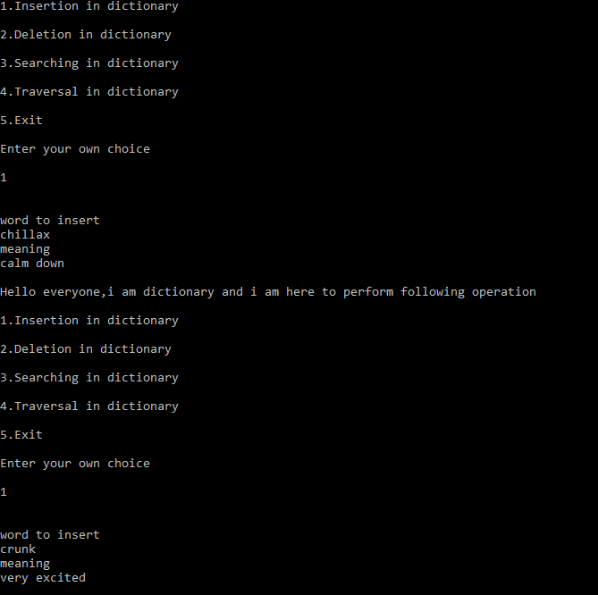

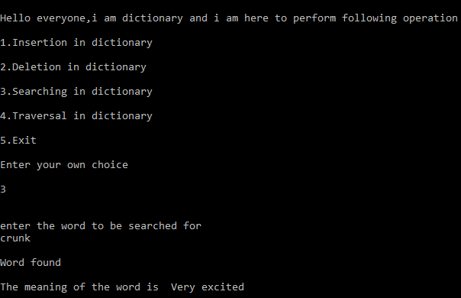

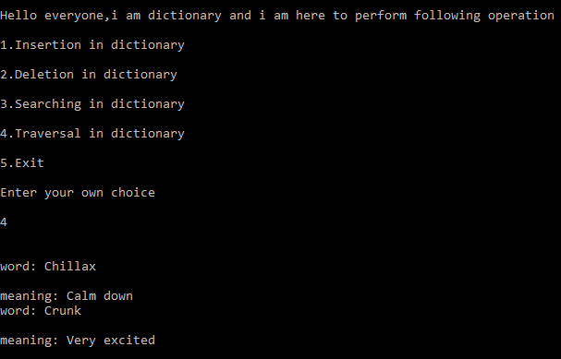

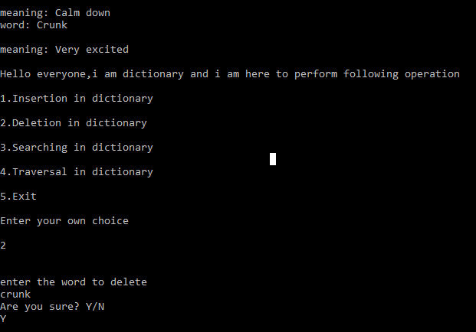

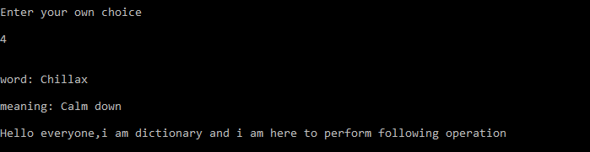
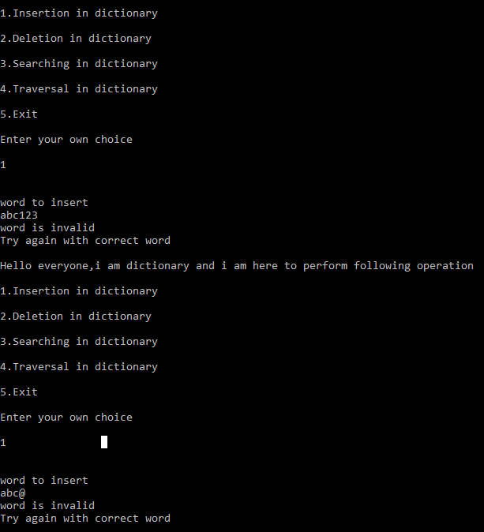

SECTION-3
DATA STRUCTURAL ANALYSIS

3.1 Data Structure Used: BINARY SEARCH TREE
Binary Search Tree, is a node-based binary tree data structure which has the following properties:
- Each node should have at most two children.
- The left subtree of a node contains only those nodes with keys lesser than the node’s key.
- The right subtree of a node contains only those nodes with keys greater than the node’s key.
- The left and right subtree each must also be a binary search tree.
There mustn’t be any duplicate nodes.

The above properties of a Binary Search Tree provide an ordering among keys so that the operations like search, minimum and maximum can be done fast. If there is no ordering, then we may have to compare every key to search a given key.
Searching a key
To search a given key in a Binary Search Tree, we first compare it with the root, if the key is present at root, we return the root. If the key is greater than the root’s key, we recur for right subtree of the root node. Otherwise we recur for left subtree.

Hash Table supports following operations in Θ(1) time.
1) Search
2) Insert
3) Delete
The time complexity of above operations in a self-balancing Binary Search Tree (BST) (like Red-Black Tree, AVL Tree, Splay Tree etc.) is O(log(n)).
So, hash table seems to be beating BST in all common operations. When should we prefer BST over Hash Tables, what are its advantages. Following are some important points in favor of BSTs.
- We can get all keys in sorted order by just doing In-order Traversal of the BST. This is not a natural operation in Hash Tables and requires extra efforts.
- Doing order statistics, finding closest lower and greater elements, doing range queries are easy to do with BSTs. Like sorting, these operations are not a natural operation with Hash Tables.
- BSTs are easy to implement compared to hashing, we can easily implement our own customized BST. To implement Hashing, we generally rely on libraries provided by programming languages.
- With Self-Balancing BSTs, all operations are guaranteed to work in O(log(n)) time. But with Hashing, Θ(1) is average time and some particular operations may be costly, especially when table resizing happens.

3.1 Search and Traversal Technique Used: IN ORDER TRAVERSAL
Unlike linear data structures (Array, Linked List, Queues, Stacks, etc.) which have only one logical way to traverse them, trees can be traversed in different ways. Following are the generally used ways for traversing trees.
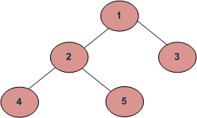
Example Tree
Depth First Traversals:
(a) In-order (Left, Root, Right): 4 2 5 1 3
(b) Preorder (Root, Left, Right):1 2 4 5 3
(c) Post-order (Left, Right, Root):4 5 2 3 1
Breadth First or Level Order Traversal: 1 2 3 4 5
In case of binary search trees (BST), In-order traversal gives nodes in non-decreasing order. To get nodes of BST in non-increasing order, a variation of In-order traversal where In-order traversal s reversed, can be used.
Example: In-order traversal for the above given figure is 4 2 5 1 3.
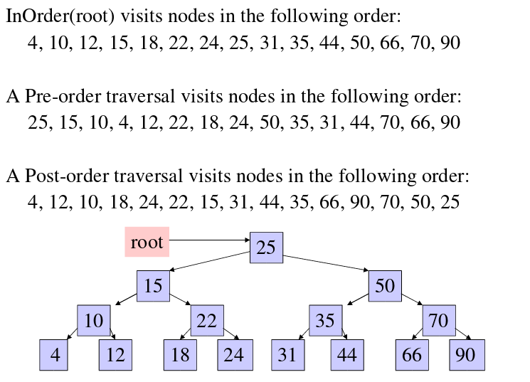

Time Complexity: O(n)
Let us see different corner cases.
Complexity function T(n) — for all problem where tree traversal is involved — can be defined as:
T(n) = T (k) + T (n – k – 1) + c
Where k is the number of nodes on one side of root and n-k-1 on the other side.

SECTION-4
METHODOLOGY

4.1 Flowchart for the project

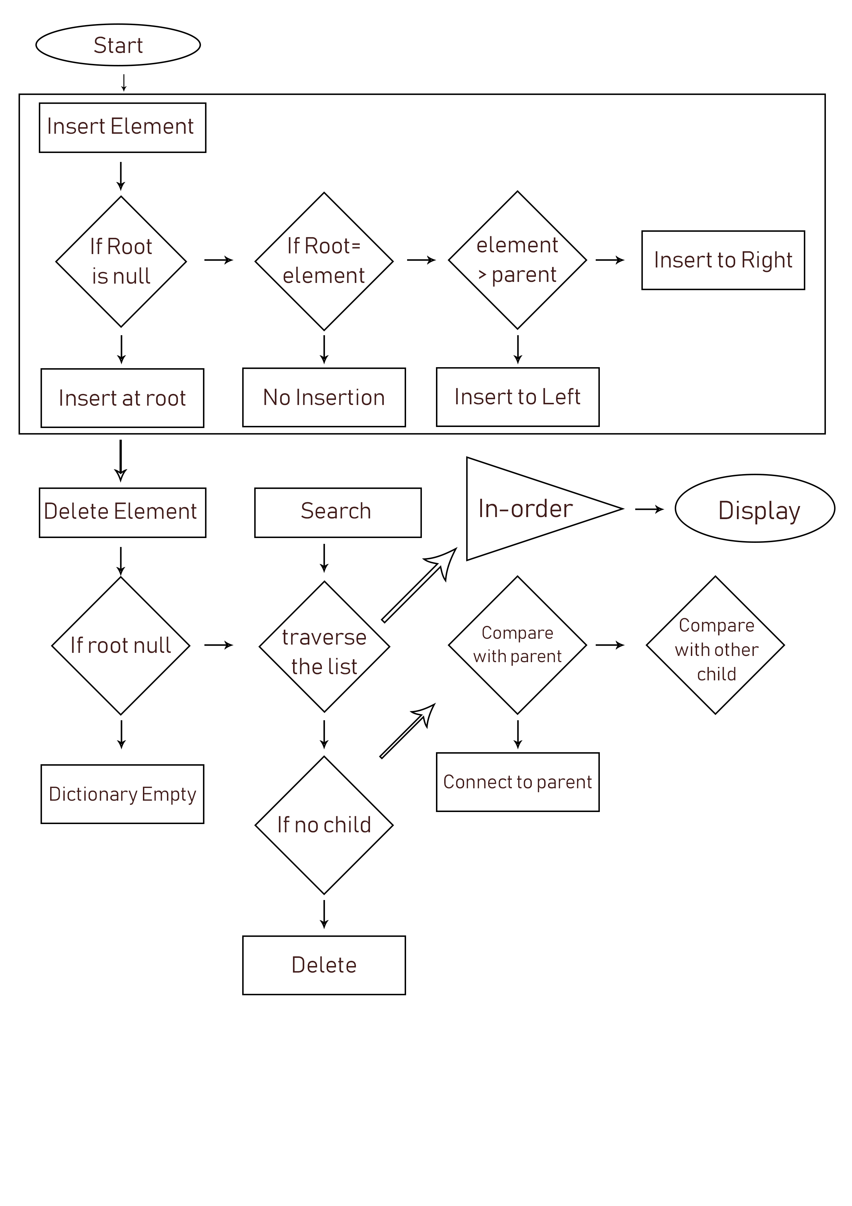
SECTION-5
TIME AND SPACE COMPLEXITIES

5.1 TIME COMPLEXITY

In computer science, the time complexity is the computational complexity that measures or estimates the time taken for running an algorithm. Time complexity is commonly estimated by counting the number of elementary operations performed by the algorithm, supposing that an elementary operation takes a fixed amount of time to perform. Thus, the amount of time taken and the number of elementary operations performed by the algorithm differ by at most a constant factor.

Time Complexity of Dictionary: BIG θ(log(n))

5.2 SPACE COMPLEXITY

Space complexity is a measure of the amount of working storage an algorithm needs, that means how much memory, in the worst case, is needed at any point in the algorithm. As with time complexity, we're mostly concerned with how the space needs grow, in big-oh terms, as the size n of the input problem grows.

Space Complexity of Dictionary: BIG θ(n)

SECTION-6
RESULT

We have successfully implemented the dictionary by implementing the Binary Search Tree data structure. In this dictionary we can search an element, we can display words in alphabetical order, we can delete a word. Thus, we have developed a fully running basic dictionary on the basis of the concepts and our learning of data structures.

SECTION-7
REFERENCES

1. Geeksforgeeks.org
2. https://www.tutorialspoint.com/java/java_dictionary_class.htm
3. https://stackoverflow.com/questions/13543457/how-do-you-create-a-dictionary-in-java
4. http://see-programming.blogspot.in/2013/05/implement-dictionary-using-binary.html
5. https://www.eecs.yorku.ca/course_archive/2010-11/W/2011/Notes/s11_bin_search_trees.pdf

